Report of | Meeting | Date
Deputy Chief Executive  (Introduced by Deputy Leader and Cabinet Member (Health and Wellbeing)) | Cabinet | Wednesday, 23 March 2022
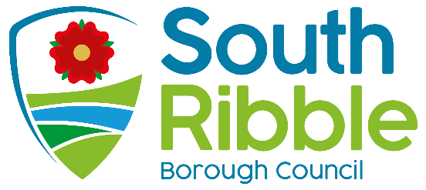

Final Report and Recommendations of the Scrutiny Review of Health Inequalities

Is this report confidential? | No

Is this decision key? | No

Purpose of the Report

- To present Cabinet with the final report from the Scrutiny Committee’s review of Health Inequalities.

Recommendations to Cabinet

- That Cabinet consider and respond to the recommendations of the Scrutiny Review of Health Inequalities.

Reasons for recommendations

- As part of the governance arrangements of the Council and Scrutiny regulations, Cabinet is required to respond to recommendations referred to it by the Scrutiny Committee.

- To ensure that the Council continues to place the health and wellbeing of residents at the forefront of its work and to support the Council’s vision for “a healthy and happy community, flourishing together in a safer and fairer borough that is led by a council recognised for being innovative, financially sustainable and accountable.”

Other options considered and rejected

- No other options were considered.

Corporate priorities

- The report relates to the following corporate priorities: (please bold all those applicable):

An exemplary council | Thriving communities
A fair local economy that works for everyone | Good homes, green spaces, healthy places

Background to the report

- As part of the Scrutiny Committee’s work programming, which includes looking at the key issues affecting the Borough, it was felt appropriate for the Scrutiny Committee to again form a task group to review health inequalities across South Ribble.

- The task group was made up of:

- Councillor David Howarth (Chair)
- Councillor Will Adams
- Councillor Colin Coulton
- Councillor Matthew Trafford
- Councillor Karen Walton

- The task group started its review in October 2020 and completed its work by November 2021, with slight delay caused by restrictions on holding face-to-face meetings due to COVID.

- The final report from the review, attached at Appendix 1, was agreed by the Scrutiny Committee on 11 January 2022 (minute 30 refers).

- The final report from the Task Group was presented to Full Council on 26 January 2022 (minute 86 refers) and it was agreed that the recommendations be considered by Cabinet for implementation.

- A draft response to each of the recommendations has been put together and attached at Appendix 2 to enable Cabinet to consider each recommendation.

- Cabinet is therefore asked to consider each recommendation and respond to the Scrutiny Committee’s recommendations.

- The Scrutiny Committee will then monitor the implementation of the recommendations as part of its monitoring and tracking process.

Climate change and air quality

- The work noted in this report does not impact the climate change and sustainability targets of the Councils Green Agenda and all environmental considerations are in place.

Equality and diversity

- There are no equality or diversity implications immediately arising from this report. It is anticipated, however, that the recommendations of the task group will enhance the health and quality of life of all demographics within South Ribble.

Risk

- There are no risks identified with any of the information contained within this report.

Comments of the Statutory Finance Officer

- There are no financial implications at this stage.

Comments of the Monitoring Officer
- It is for Cabinet to decide how to respond to the recommendations of this Scrutiny Review. There are no concerns with this report from a Monitoring Officer perspective.

Background documents

‘Mind the Gap’: 2013 Scrutiny Review into Health Inequalities

Appendices

Appendix 1 – Final Report of the Scrutiny Review Task Group into Health Inequalities
Appendix 2 – Draft Responses to Recommendations

Report Author: | Email: | Telephone: | Date:
Charlotte Lynch (Democratic and Member Services Officer) | charlotte.lynch@southribble.gov.uk | 01772 625563 | 16/02/2022

